ASSIGNMENT – 10

Joining a Table to Itself

Q1) write a query that produces all pairs of a salespeople who are living in the same city. Exclude combinations of salespeople with themselves as well as a duplicate rows with the order reversed.

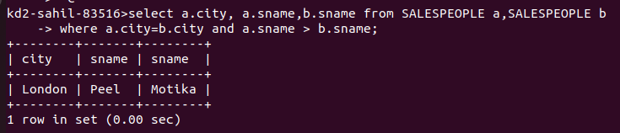

Q2) Write a query that produces the names and the cities of all customers with the same rating as Hoffman.

